Minesweeper: how to play

Minesweeper is a deceptively simple test of memory and reasoning—and one of the most popular Windows games of all time. The goal: find the empty squares and avoid the mines.

Sounds easy, right?

Start game

Change game options

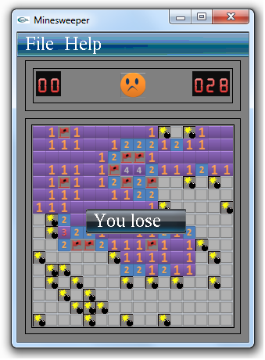

1. [Click to open Games.](shortcut:shell:::%7bED228FDF-9EA8-4870-83B1-96B02CFE0D52%7d)
2. Double-click Minesweeper.

(Don't see it? You might need to turn on Windows Games. See [Where are my games?](mshelp://windows/?id=14caf22a-89a4-4700-b148-8da4f9127733))

1. Choose a difficulty level—Beginner, Intermediate, or Advanced.
2. To start, click a tile.

If you need to finish a game later, you can exit the game and then click Save. The next time you play, you'll be asked whether you want to continue your last game. If so, click Yes.

*You can adjust the difficulty level, turn animation on and off, and more.*

1. [*Click to open Games.*](shortcut:shell:::%7bED228FDF-9EA8-4870-83B1-96B02CFE0D52%7d)
2. *Double-click Minesweeper.*

*(Don't see it? You might need to turn on Windows Games. See* [*Where are my games?*](mshelp://windows/?id=14caf22a-89a4-4700-b148-8da4f9127733)*)*

1. *Click the Game menu, and then click Options.*
2. *Make your choices, and then click OK.*

*You can change the board color, and whether it conceals mines or flowers.*

1. [*Click to open Games.*](shortcut:shell:::%7bED228FDF-9EA8-4870-83B1-96B02CFE0D52%7d)
2. *Double-click Minesweeper.*

*(Don't see it? You might need to turn on Windows Games. See* [*Where are my games?*](mshelp://windows/?id=14caf22a-89a4-4700-b148-8da4f9127733)*)*

1. *Click the Game menu, and then click Change Appearance.*
2. *Make your choices, and then click OK.*

***Minesweeper*: Rules and basics**

**The object**

Find the empty squares while avoiding the mines. The faster you clear the board, the better your score.

**The board**

Minesweeper has three standard boards to choose from, each progressively more difficult.

* Beginner: 81 tiles, 10 mines
* Intermediate: 256 tiles, 40 mines
* Expert: 625 tiles, 99 mines

**How to play**

The rules in Minesweeper are simple:

* Uncover a mine, and the game ends.
* Uncover an empty square, and you keep playing.
* Uncover a number, and it tells you how many mines lay hidden in the eight surrounding squares—information you use to deduce which nearby squares are safe to click.

**Hints and tips**

* Mark the mines. If you suspect a square conceals a mine, right-click it. This puts a flag on the square. (If you're not sure, right-click again to make it a question mark.).
* Study the patterns. If three squares in a row display 2-3-2, then you know three mines are probably lined up beside that row. If a square says 8, every surrounding square is mined.
* Explore the unexplored. Not sure where to click next? Try clearing some unexplored territory. You're better off clicking in the middle of unmarked squares than in an area you suspect is mined.

Prepared by: Siddhartha Shankar das.

Student No: 0805047.

Level:1.Term:2.